Big Data Analytics

**Lab Practical and date** – Practical 8, Monday 5th October 2020

**Name and Roll Number**- Het Shah, 17BIT103

**Practical Objective**-   
Setup MongoDB environment in your system. Import Restaurant Dataset and perform CRUD operation.

**Steps Involved-**

We installed and setup mongo DB in our system and imported the Restaurant dataset and performed operations such as create, read, update and delete operations on them.

**Background**

**MongoDB**

**MongoDB** is a [cross-platform](https://en.wikipedia.org/wiki/Cross-platform) [document-oriented database](https://en.wikipedia.org/wiki/Document-oriented_database) program. Classified as a [NoSQL](https://en.wikipedia.org/wiki/NoSQL) database program, MongoDB uses [JSON](https://en.wikipedia.org/wiki/JSON)-like documents with optional [schemas](https://en.wikipedia.org/wiki/Database_schema). MongoDB is developed by [MongoDB Inc.](https://en.wikipedia.org/wiki/MongoDB_Inc.) and licensed under the Server Side Public License (SSPL).

**Restaurant dataset**

This dataset contains a list of restaurants within Baltimore City.

**Input File**

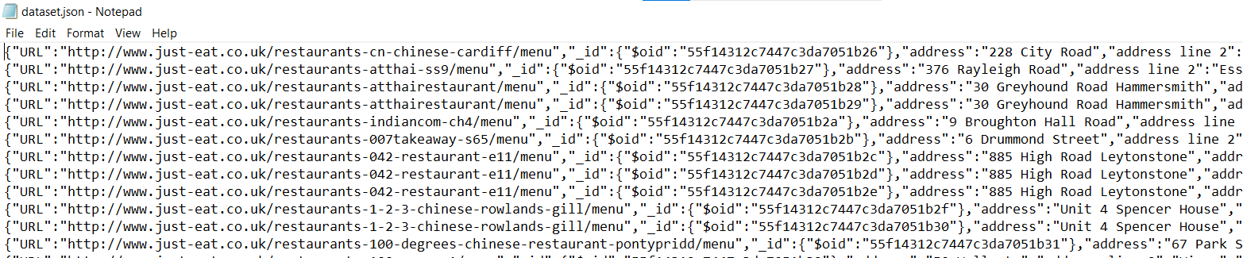

Input file is a json file which consists information about the restaruants and attricubtes such as URL, address, name, etc.

**MongoDB Installation**

1. Download the MSI installer from the MongoDB website
2. Install MongoDB with the Installation Wizard
3. Select “Run service as Network Service user”
4. Create the Data Folders to Store our Databases
5. Add the bin folder to the env variables

**Open CMD and write mongod**

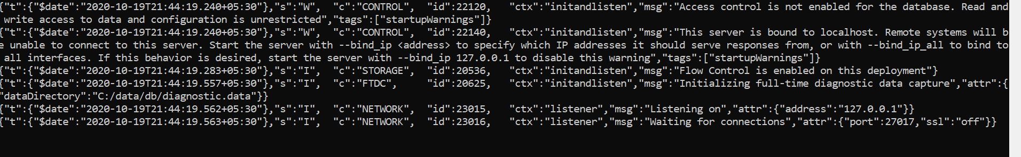

**This shows that the server has started**

**Open CMD and write mongod -version**

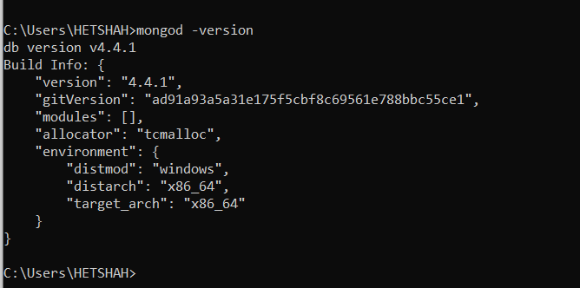

This shows the version of the mongodb installed in the system

Importing the Json file and creating the database

**mongoimport --db test --collection restaurants --drop --file E:/Desktop/dataset.json**

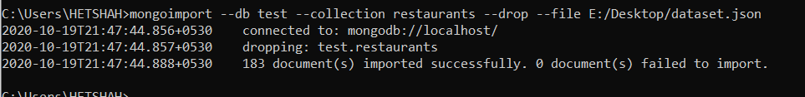

The prompt shows that 183 documents have been imported to the database

**To start the mongoDB shell write mongo.exe**

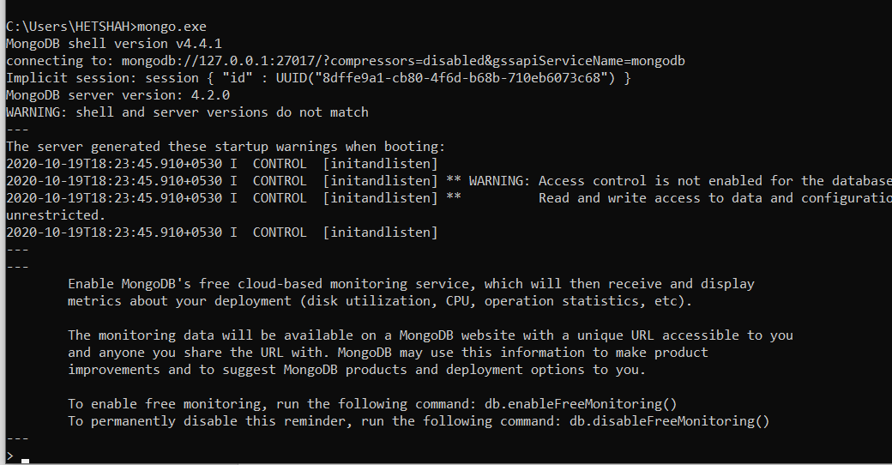

CRUD Operations

Create

We insert the following into the table

db.restaurants.insert( { "address" : { "street" : "2 Avenue", "zipcode" : "10075", "building" : "1480", "coord" : [ -73.9557413, 40.7720266 ], }, "borough" : "Manhattan", "cuisine" : "Italian", "grades" : [ { "date" : ISODate("2014-10-01T00:00:00Z"), "grade" : "A", "score" : 11 }, { "date" : ISODate("2014-01-16T00:00:00Z"), "grade" : "B", "score" : 17 } ], "name" : "Vella", "restaurant_id" : "41704620" } )

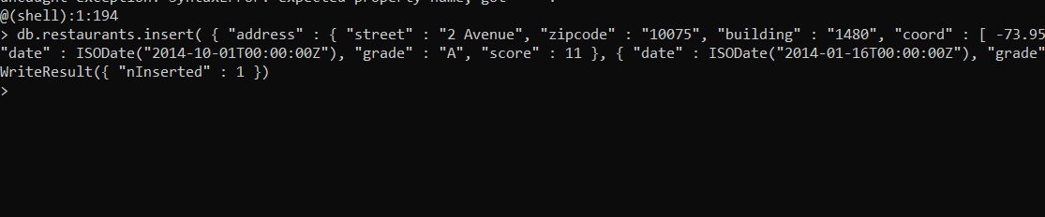

WriteResult indicates that is has been inserted successfully.

Read

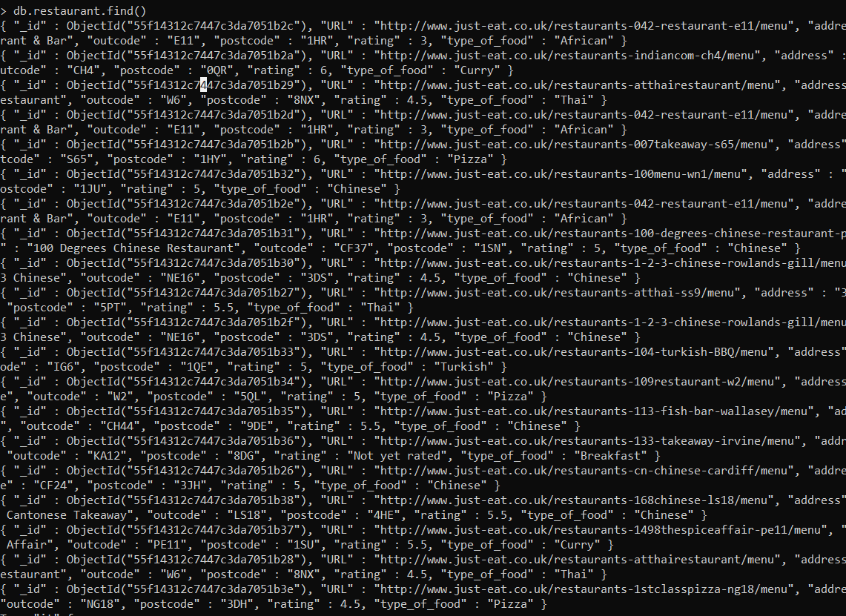

db.restaurants.find() shows all the documents in the table

**Search with a condition**

Find all the restaurants that have borough as Manhattan

db.restaurants.find( { "borough": "Manhattan" }

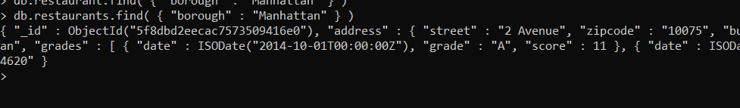

Find all the Restaurants with grade score less than 30



Combining Conditions – using OR

db.restaurants.find( { $or: [ { "cuisine": "Italian" }, { "address.zipcode": "10075" } ] } )

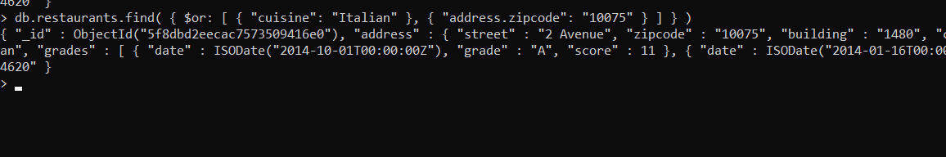

Displaying the result in a sorted manner

db.restaurants.find().sort( { "borough": 1, "address.zipcode": 1 } )

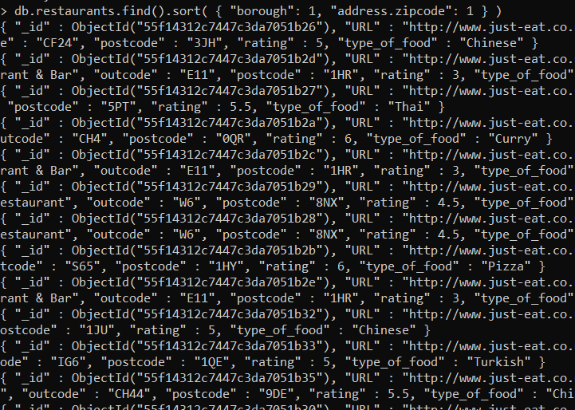

**Update**

Update the first document with name 100 Menu and set new values

db.restaurants.update( { "name" : "100 Menu" }, { $set: { "cuisine": "American (New)" }, $currentDate: { "lastModified": true } } )



The promt shows nMatched and nModified as 1 showing that the value was updated

**Delete**

db.runCommand(

{

delete: "orders",

deletes: [ { q: { status: "D" }, limit: 1 } ]

}

)

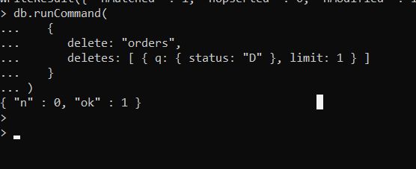

Delete Command

**Conclusion**

In this practical we learned MongoDB installation and how to import dataset and perform basic crud functions